Power Bi Inflation Analysis: Journeying Through Global Economic

# Team Details:

**Team ID:** LTVIP2025TMID19907

**Team Leader:** Kunapareddy Asritha (21481A5468) Mail id[asrithakunaparedy@gmail.com](mailto:asrithakunaparedy@gmail.com)

**Team member:** Matangi Sarojini (21481A5478)

Mail id: [matangisarojini29@gmail.com](mailto:matangisarojini29@gmail.com)

**Team member:** Thopula Guna Raji (22485A5412)

Mail id: [gunathopula@gmail.com](mailto:gunathopula@gmail.com)

**Team member:** Kurella Ramu (21481A5469)

Mail id: [ramukurella22@gmail.com](mailto:ramukurella22@gmail.com)

# Technologies used:

Excel/CSV – Used as the dataset source.

Power Query – For data cleaning and transformation.

DAX (Data Analysis Expressions) – For creating calculated measures and aggregations.

Power BI – For data visualization and dashboard creation.

# Introduction:

This project aims to analyse inflation trends across different countries using Power BI. By leveraging data visualization techniques, the project provides insights into inflation rates, contributing factors, and economic impacts. The analysis enables stakeholders to understand economic fluctuations, assess policy effectiveness, and make data-driven decisions.

Through rigorous examination of inflation metrics, including consumer price index (CPI), producer price index (PPI), and inflation trends over time, stakeholders will gain actionable insights to mitigate economic risks and formulate effective strategies. Ultimately, the goal is to empower policymakers, businesses, and financial analysts with the tools and insights necessary to navigate inflationary pressures and drive sustainable economic growth.

# Scenario 1 - Government Policy & Economic Planning:

A government agency wants to monitor inflation trends to formulate economic policies and stabilize market conditions. By using "Power BI Inflation Analysis", they can track key inflation indicators in real time, identify economic patterns, and assess the impact of fiscal and monetary policies. This allows them to make informed decisions, such as adjusting interest rates or implementing subsidies, to control inflation and promote economic stability.

# Scenario 2 - Business Strategy & Cost Management:

A multinational corporation (MNC) wants to assess inflationary effects on operational costs and pricing strategies. Using "Power BI Inflation Analysis", they can visualize inflation trends across different regions and analyse factors such as raw material costs, labour expenses, and currency fluctuations. With interactive dashboards, they can adjust pricing models, optimize supply chains, and manage financial risks effectively, ensuring profitability and competitive advantage.

# Scenario 3 - Investment & Financial Market Analysis:

An investment firm wants to analyse inflation trends to make data-driven investment decisions. By integrating "Power BI Inflation Analysis", they can track inflation’s impact on stock markets, bonds, and commodities in different economies. The insights help them predict market trends, identify safe-haven assets, and adjust investment portfolios accordingly. Additionally, they can use inflation forecasts to advise clients on wealth management and financial planning strategies.

# Technical Architecture:

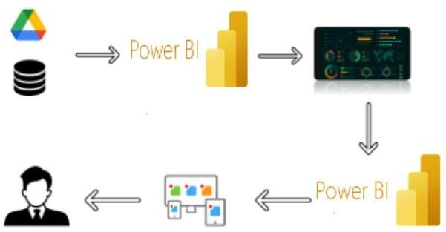

**Project Flow**

To accomplish this, we have to complete all the activities listed below,

# Data Collection & Extraction from Database

* + Collect the dataset
  + Storing Data in DB
  + Perform SQL Operations
  + Connect DB with Power BI

# Data Preparation

* + Prepare the Data for Visualization

# Data Visualizations

* + No of Unique Visualizations

# Dashboard

* + Responsive and Design of Dashboard

# Report

* + Responsive and Design of Dashboard

# Performance Testing

* + No of Visualizations/Graphs

# Project Demonstration & Documentation

* + Record explanation Video for project end-to-end solution
  + Project Documentation – Step-by-step project development procedure

# Milestone 1: Data Collection & Extraction from Database Introduction

Data collection is the process of gathering and measuring information on variables of interest in a systematic manner. This enables answering research questions, testing hypotheses, evaluating outcomes, and generating insights from the data.

# Activity 1: Collect the Dataset

Please use the link to download the dataset: Dataset link

# Activity 1.1: Understand the Data

The dataset contains all the meta-information regarding the columns described in the global_inflation_data.csv file. Below is the description of the key columns:

The dataset contains global inflation data for various countries from 1980 to 2024. It includes:

* 196 rows (countries) and 47 columns (years + metadata).
* Columns:
  + country_name: Name of the country.
  + indicator_name: Type of inflation metric (all seem to be "Annual average inflation (consumer prices) rate").
  + 1980 - 2024: Annual inflation rates (percentage values) for each country.

# Activity 2: Connect Data with Power BI

With Power BI, users can seamlessly connect to a wide range of data sources, including databases, cloud services, spreadsheets, and APIs. This enables organizations to consolidate various data sources into a single, unified platform for comprehensive analysis.

# Steps to Connect the Dataset in Power BI:

1. Open Power BI Desktop.
2. Click on "Get Data" → Select "CSV" → Locate global_inflation_data.csv → Click "Load".
3. Preview the data and ensure all columns are correctly formatted.
4. Perform basic transformations (e.g., renaming columns, changing data types, handling missing values).
5. Establish relationships between different data tables (if multiple datasets are used).
6. Apply filters and data cleaning techniques to ensure accuracy.
7. Save the dataset and proceed with visualization. Explanation video link:

<https://drive.google.com/file/d/13R0y2xmnhQZ-9vlXdXcamuo1y_bsMYD2/view?usp=sharing>

# Milestone 2: Data Preparation Introduction

Data preparation is a critical phase in the data lifecycle, ensuring that raw data is transformed into a structured and analysable format. This phase involves multiple steps, including data cleaning, integration, transformation, and enrichment. Ensuring data accuracy and consistency is crucial for deriving meaningful insights.

# Activity 1: Prepare the Data for Visualization Steps Involved in Data Preparation:

1. **Data Cleaning:**
   * Identify and remove duplicates.
   * Handle missing or null values (e.g., using mean imputation or removing incomplete records).
   * Standardize numerical values (e.g., convert inflation rates to percentages).
   * Correct inconsistencies in country names or date formats.

# Data Transformation:

* + Convert data types where necessary (e.g., ensure numerical fields like CPI, GDP growth, and Interest Rates are in correct formats).
  + Aggregate data (e.g., compute annual average inflation rates per country).
  + Create calculated columns (e.g., Inflation Rate Change = CPI Year 2 - CPI Year 1).

# Created New Columns:

* + Index: The row number, uniquely identifying each country entry in the dataset.
  + Inflation rate: It represent the annual percentage change in consumer prices for each country.
  + Adjusted inflation rate: It represent the annual percentage change in consumer prices for each country * 0.1
  + Inflation rate category: The inflation rate is categorized as Low (<2%), Moderate (2%-5%), or High (≥5%) based on annual percentage changes in consumer prices.

# Data Integration:

* + Combine multiple datasets for a more comprehensive analysis.
  + Establish relationships between tables if using multiple data sources.

# Preparing for Visualization:

* + Ensure data is structured for easy visualization in Power BI.
  + Verify column names and ensure all relevant data is included.
  + Save the cleaned dataset for further visualization in Power BI.

# Milestone 3: Data Visualization

Data visualization is the process of graphically representing data to make complex information more accessible, interpretable, and insightful. The goal is to use visual elements like charts, graphs, and maps to identify patterns, trends, and outliers in global inflation data. By leveraging Power BI's interactive capabilities, we can present inflation-related insights in an intuitive manner, aiding decision-makers in understanding economic shifts.

# Activity 1: Number of Unique Visualizations

The dataset allows the creation of multiple unique visualizations to explore inflation trends across different regions and economic factors. Below are some key types of visualizations that can be used:

# Bar Charts

* + Compare inflation rates across different countries and regions.
  + Analyse inflation trends across different years.

# Line Charts

* + Show year-over-year inflation rate changes.
  + Track inflation trends alongside GDP growth or interest rates.

# Heat Maps

* + Display inflation severity across global regions.
  + Show month-wise inflation variations in different countries.

# Pie Charts

* + Show inflation contribution by different regions or economic sectors.
  + Break down consumer price index (CPI) components.

# Maps (Geospatial Visualizations)

* + Visualize inflation rates across different countries.
  + Compare regional inflation trends over time.

Activity 1.1 – Sum of Inflation Rate by Year

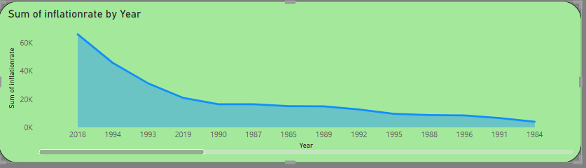

Activity 1.2 – Sum of Inflation Rate by Inflation Rate Category

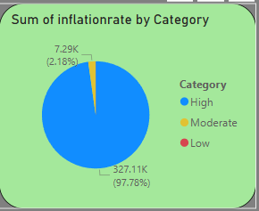

Activity 1.3 – Average of Adjusted Inflation Rate

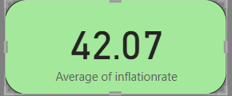

Activity 1.4 – Sum of Inflation Rate by country name

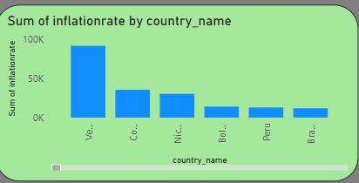

Activity 1.5 – Sum of Adjusted Inflation Rate

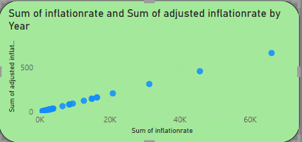

Activity 1.6 –Distribution of Inflation Rate Category

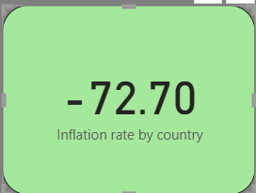

Activity 1.7 – Count of year and sum of inflation rate

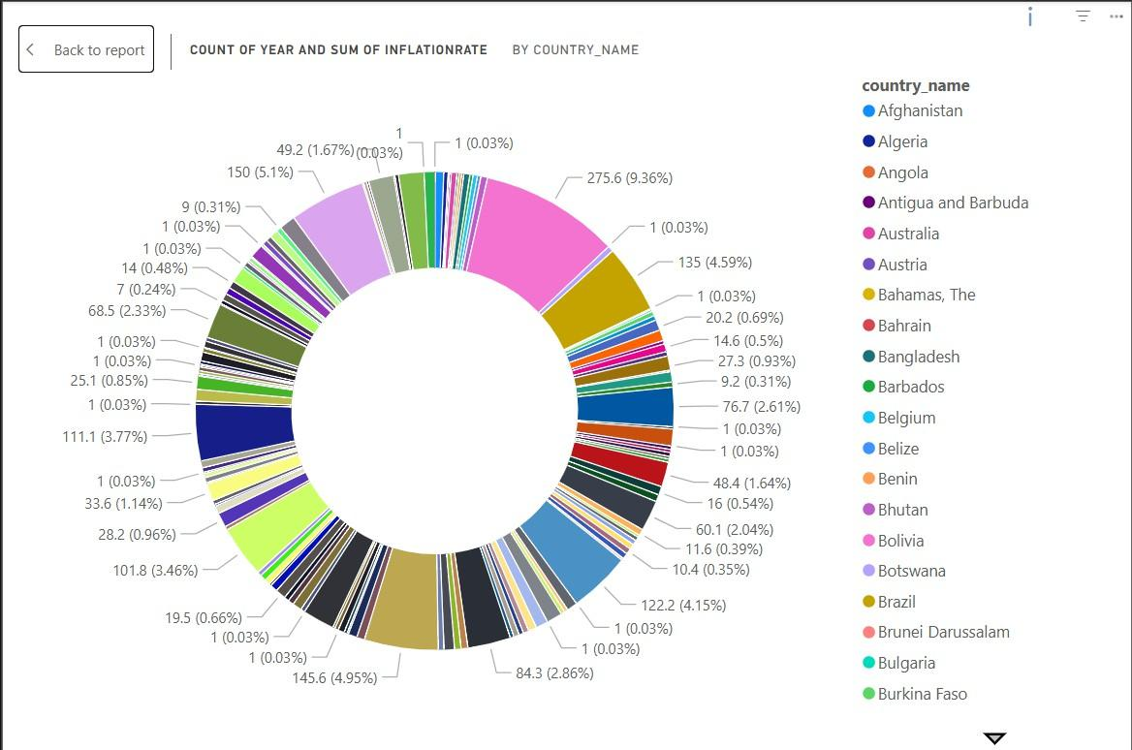

Activity 1.8 – Sum of Adjusted Inflation rate in graph

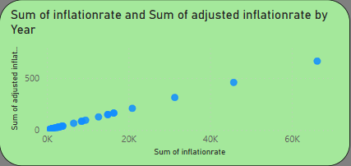

Activity 1.9 – Average of Inflation Rate

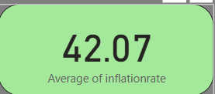

Activity 1.10 – Maximum Inflation Rate

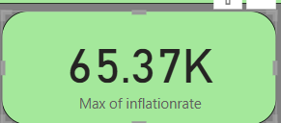

# Milestone 4: Dashboard

A dashboard is a graphical user interface (GUI) that provides a centralized and interactive view of key data insights. In this Power BI Inflation Analysis project, the dashboard enables users to monitor inflation trends, assess economic performance, and analyse key indicators through interactive visual representations such as charts, graphs, and tables.

By presenting real-time and historical data in an intuitive and structured format, the dashboard enhances decision-making for policymakers, economists, and businesses. The primary goal is to track inflation trends across countries, analyse influencing factors, and derive meaningful economic insights.

# Activity 1: Responsive and Interactive Dashboard Design Key Components of the Power BI Dashboard

1. Header Section (KPI Cards)
   * Global Average Inflation Rate: Provides a quick snapshot of worldwide inflation trends.
   * Maximum Inflation Rate: Displays the highest recorded inflation rate across countries.
2. Inflation Trends (Line & Bar Charts)
   * Inflation Rate Comparison Across Years: Visualizes how inflation has fluctuated over time.
3. Geographical Analysis (Map Visualization)
   * Country-wise Inflation Impact: Allows users to compare inflation effects on different economies.
4. Interactive Reports & AI-Driven Insights Panel
   * Identifies Key Economic Patterns: Uses historical inflation data to detect long-term trends and anomalies.
   * Provides Actionable Recommendations: AI-driven insights help forecast potential inflationary risks and suggest policy adjustments.

**Video Explanation:**

[https://drive.google.com/file/d/1cOcwCJZkVMPrp16lqNv3sa5dZIitEyQJ/view?usp=sharing](https://drive.google.com/file/d/1cOcwCJZkVMPrp16lqNv3sa5dZIitEyQJ/view?usp=sharing%20)

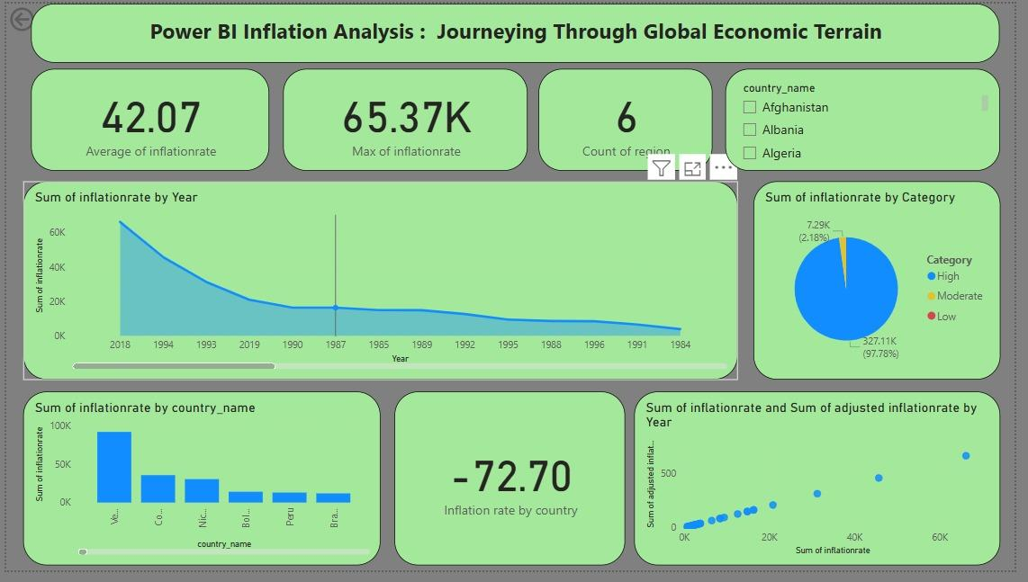

# Milestone 5: Report

A data report is a structured narrative representation of data and its analysis. The primary goal is to present complex economic trends, patterns, and insights in a manner that is engaging and easy to understand.

In this Power BI Inflation Analysis project, the report narrates the global inflation trends, influencing factors, and their impact on different economies. Using interactive dashboards, data visualizations, and storytelling techniques, the report provides valuable insights for policymakers, businesses, and economists.

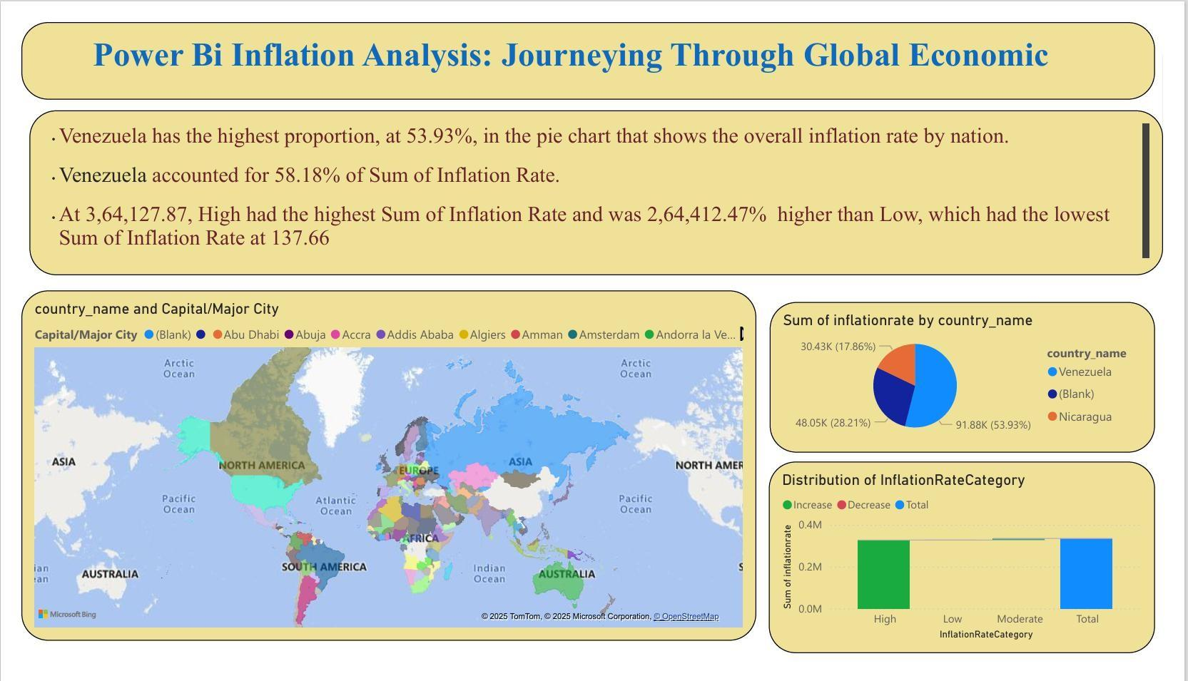

# Milestone 6: Performance Testing

Performance testing is a crucial aspect of software development aimed at evaluating the speed, response, stability, and scalability of an application under various workload conditions. It involves simulating real-world usage scenarios to assess how the system behaves and performs under stress, peak loads, or normal conditions.

# Activity 1: Utilization of Data Filters

The utilization of data filters plays a pivotal role in streamlining information processing and analysis across various domains. By selectively extracting or excluding specific data points based on predefined criteria, filters enable efficient data management and enhance decision- making processes.

1. Sum of Inflation Rate by Year

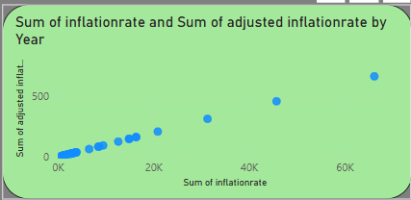

1. Sum of Inflation Rate by country name

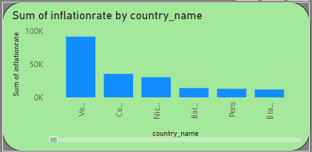

# Activity 2: No of Visualizations/ Graphs

1. Sum of Inflation Rate by Year
2. Sum of Inflation Rate by country name
3. Average of Adjusted Inflation Rate
4. Average of Inflation Rate
5. Sum of Inflation Rate by Inflation Rate Category
6. Distribution of Inflation Rate Category
7. Maximum Inflation Rate
8. Sum of Adjusted Inflation rate
9. displaying country name
10. Count of year and sum of inflation rate
11. Sum of Adjusted Inflation Rate
12. Year Count

# Milestone 7 : Project Demonstration & Documentation

Below mentioned deliverables to be submitted along with other deliverables

# Activity 1- Record explanation Video for project end to end solution

Creating a record explanation video for a project's end-to-end solution is crucial for ensuring clarity and transparency in its implementation. This video serves as a comprehensive guide, detailing every aspect of the project from inception to completion.

# Explanation video:

<https://drive.google.com/file/d/1cOcwCJZkVMPrp16lqNv3sa5dZIitEyQJ/view?usp=sharing>

# Activity 2-Project Documentation-Step by step project development procedure

Create document as per the template provided

1. Imported Dataset into Power BI.
2. Performed Data Cleaning & Transformation using Power Query.
3. Created New Columns & Measures for deeper analysis.
4. Designed Data Visualizations & Dashboard.
5. Developed & Published Power BI Report.
6. Conducted Performance Testing to optimize efficiency.
7. Finalized Documentation for better project presentation.